Contents

**Guru Ram Das Jayanti: A Historical Perspective** 1

**Introduction** 1

**Early Life of Guru Ram Das Ji** 1

**Contributions to Sikhism** 1

**1. Founding of Amritsar** 1

**2. Institutional Development** 1

**3. Spiritual Teachings** 2

**Celebration of Guru Ram Das Jayanti** 2

**Conclusion** 2

**References** 2

**Guru Ram Das Jayanti: A Historical Perspective**

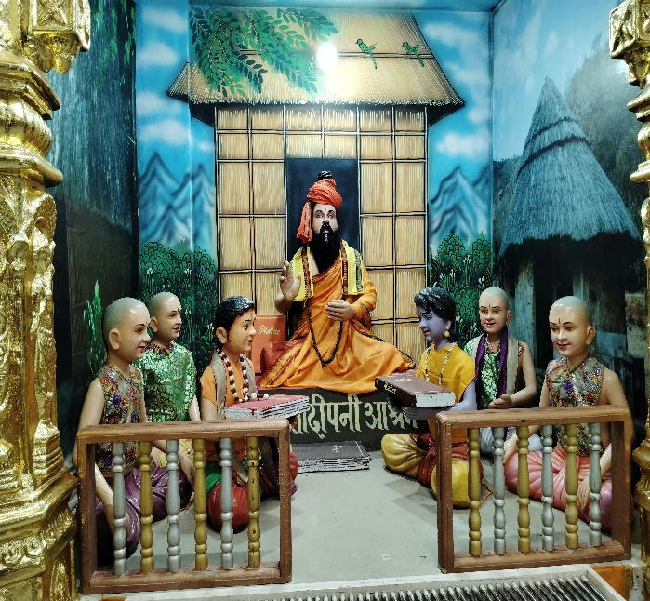**Introduction**

Guru Ram Das Jayanti marks the birth anniversary of **Guru Ram Das Ji**, the fourth of the ten Sikh Gurus. Celebrated with devotion by Sikhs across the world, this day is an important religious and cultural observance. Guru Ram Das Ji played a significant role in shaping Sikhism, promoting humility, service, and the establishment of Amritsar as a spiritual center.

**Early Life of Guru Ram Das Ji**

Guru Ram Das Ji was born on **24 September 1534** in **Lahore** (in present-day Pakistan) as **Bhai Jetha Ji** into a humble family. Orphaned at a young age, he was raised by his maternal grandmother. From early on, he exhibited qualities of piety, humility, and a deep devotion to God.

He later met Guru Amar Das Ji, the third Sikh Guru, and became one of his most devoted disciples. Guru Amar Das Ji was so impressed by Bhai Jetha’s dedication that he married his daughter, Bibi Bhani, to him. Eventually, Guru Ram Das Ji was appointed as the fourth Guru in **1574**.

**Contributions to Sikhism**

**1. Founding of Amritsar**

One of Guru Ram Das Ji’s most notable contributions was laying the foundation for the city of **Amritsar**. He began the excavation of the **Amrit Sarovar** (holy tank), around which the **Golden Temple** (Harmandir Sahib) would later be built. This city became the spiritual center of Sikhism.

**2. Institutional Development**

Guru Ram Das Ji systematized the **Masand system**, a missionary and donation-collection system that helped spread Sikh teachings and supported the community financially. He emphasized **seva** (selfless service), **kirtan** (devotional singing), and **langar** (community kitchen).

**3. Spiritual Teachings**

Guru Ram Das Ji composed **638 hymns** included in the **Guru Granth Sahib**, the Sikh holy scripture. His hymns focus on humility, service, love, and devotion to God. One of his most famous compositions is the **Laavan**, the four hymns recited during the Sikh wedding ceremony (Anand Karaj).

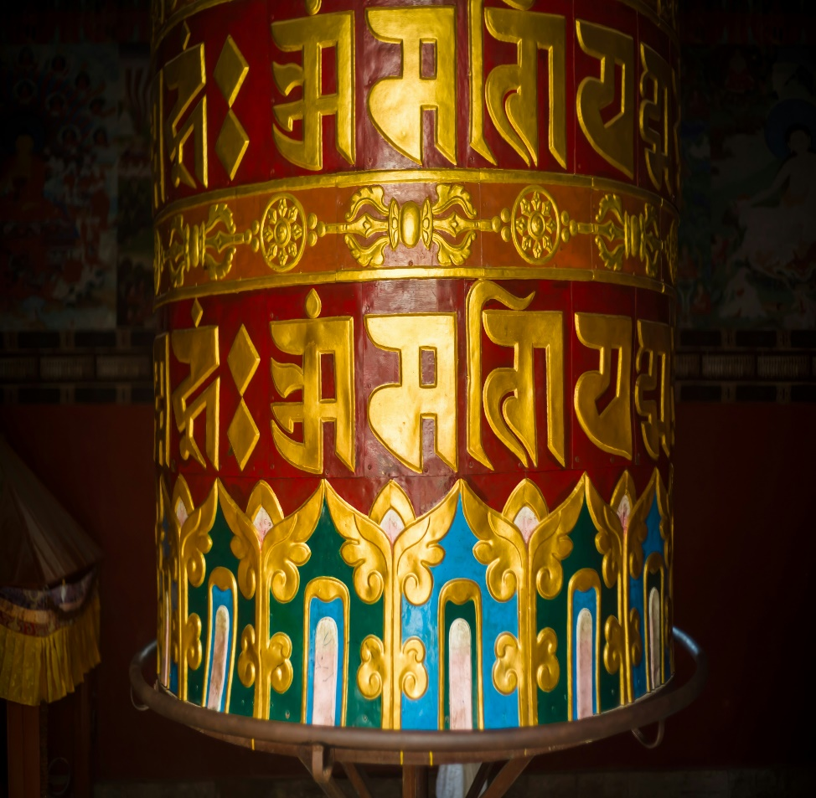**Celebration of Guru Ram Das Jayanti**

Guru Ram Das Jayanti is usually celebrated according to the **Nanaksahi calendar**, often falling in **October**. Devotees visit gurdwaras, sing hymns, participate in **Akhand Path** (continuous reading of the Guru Granth Sahib), and engage in acts of charity. Special celebrations are held at **Gurdwara Ramsar Sahib** and **Sri Harmandir Sahib** in Amritsar.

**Conclusion**

Guru Ram Das Jayanti is not just a celebration of a revered Guru’s birth but a reminder of his profound impact on Sikhism. His teachings of humility, service, and devotion continue to guide millions. His role in shaping Amritsar as a spiritual nucleus and his literary contributions to Sikh scripture make Guru Ram Das Ji an enduring figure in Indian and Sikh history.

**References**

1. Singh, Khushwant. *A History of the Sikhs*. Oxford University Press, 2004.
2. Dhillon, Dalbir Singh. *Sikhism: Origin and Development*. Atlantic Publishers, 1988.
3. Singh, Patwant. *The Sikhs*. Rupa Publications, 2000.